- Give a brief explanation about the lab. (i.e. – What did you do and what did the lab involve?)

- What was your favorite part of the lab?

- List two things you learned during the course of the lab.

- Explain why the metric system is important to use in science.

- Accurately read the mass of the triple beam balance pictured below.
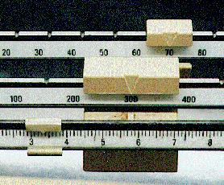 Mass: _________________

- Accurately read the volume of the graduated cylinder pictured below.
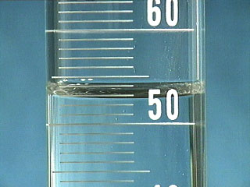 Volume: _________________

- What is the temperature the thermometer below?
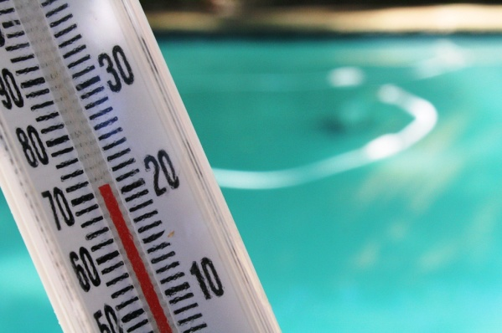 Temperature: _________________
F C

- What is the area of the object below?
5.2 cm

9.1 cm Area: _______________

